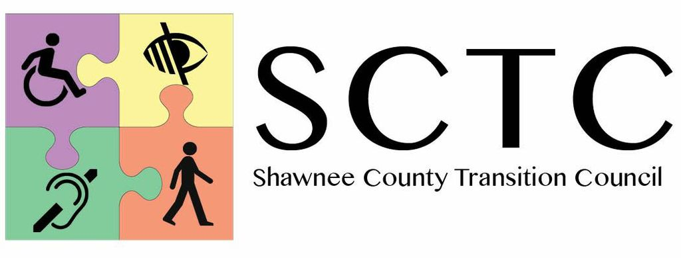
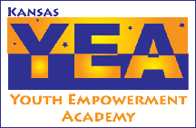

Liability Release Form
Kansas Youth Empowerment Academy (KYEA) &
Shawnee County Transition Council (SCTC)
Liability Release Form

I, the undersigned, do hereby agree to assume all risk and responsibilities surrounding my participation in the Disability Mentoring Day activities. I do for myself, my heirs, executors, and administrators hereby defend, hold harmless, indemnify, release, and all its officer, agents, and employees from and against any and all claims, demands and actions, or cause of action, on account of damage to personal property, or personal injury, or death which may result from participation, and which result from causes beyond the control of, and without the fault of negligence of the KYEA & SCTC, it’s officers, agents or employees, during the period of my participation in Disability Mentoring Day activities.

Participant Date

Co-signature of Legal guardian (if participant is under 18 years of age) Date

Relationship to participant

